Germany 1919-1945

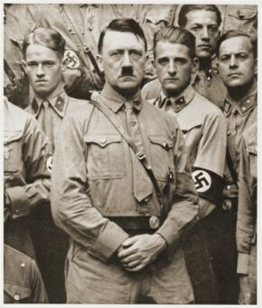

Weimar Germany – 1919-1933

The end of WW1
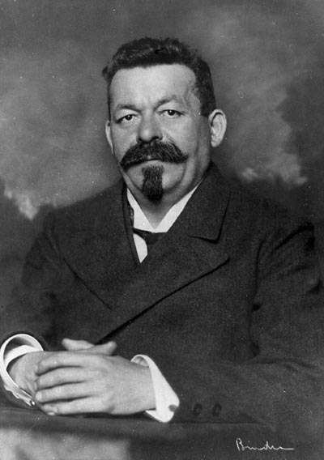
- Germany was in a very poor state: the blockade of Germany had lead to a lack of food and supplies. People were starving. Riots were breaking out. The navy had mutinied (rebelled) against the Kaiser (king of Germany).
- The Kaiser realised the situation was hopeless and abdicated (quit his job) in October 1918. Germany was left without a leader and in a mess.
- The biggest political party in Germany was the Social Democrats. Their leader, Friedrich Ebert, took on the job of running Germany. He tried to improve people’s lives by giving them better working conditions and freedom of speech.

The Spartacist Revolution January 1919
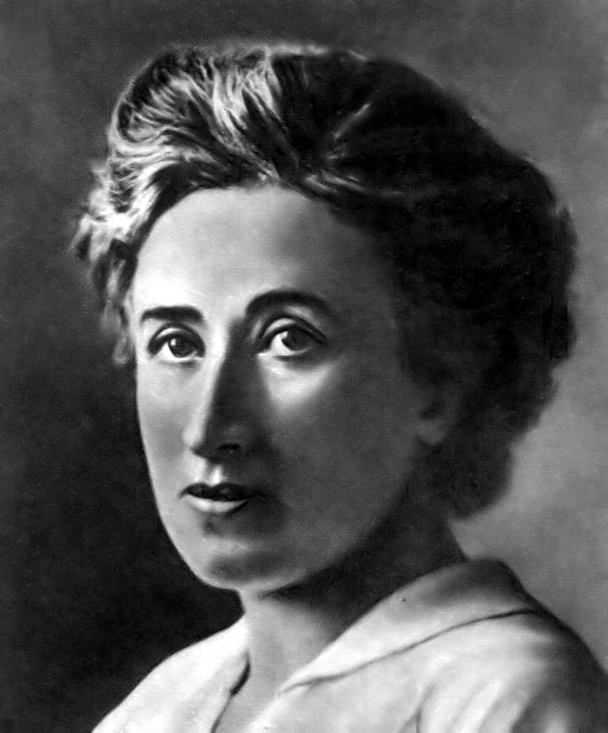
- In January 1919, the German communist party (the Spartacists) decided that they wanted to take over Germany from Ebert. They started a revolution attempt on 6 January. It was not successful – in a week, Ebert with the help of his Freikorps (ex-WW1 soldiers paid to help the government keep order) had stopped the rebellion and killed many communists. The Spartacist leaders, Rosa Luxemburg and Karl Liebnecht, were murdered.
- It was helpful for Ebert that the Spartacists were no longer a threat. However, he had to rely on the Freikorps to keep order – that made him look weak to the public, and it was risky as the Freikorps could turn on him at any point.

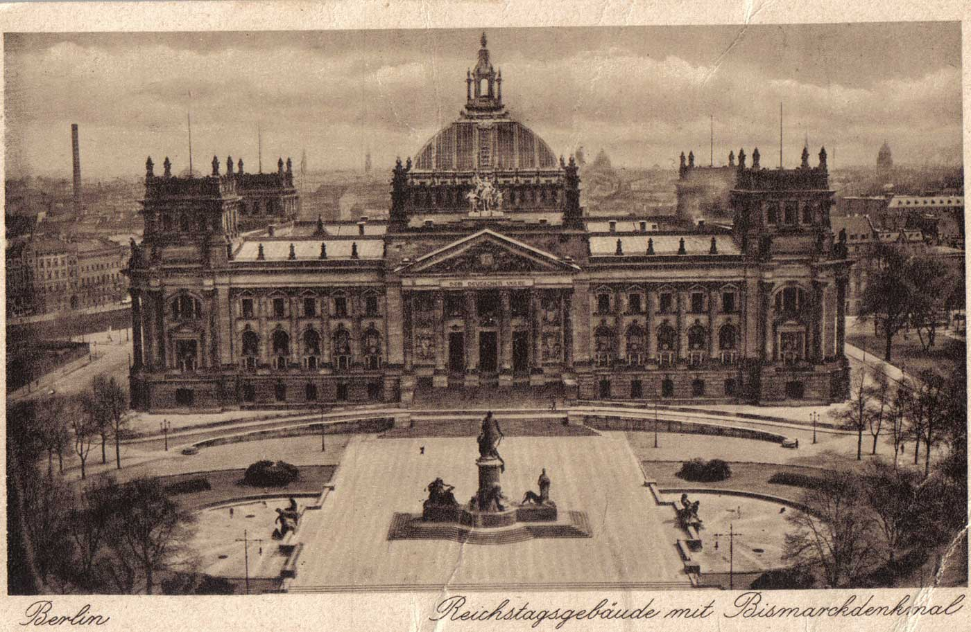
The Weimar Constitution

- The Social Democrats won the January 1919 elections. They held the first meeting of their new government in a town called Weimar – and got the nickname “The Weimar Government”. Their first task was to write a new constitution for Germany.
- Their new rules included:
- Everyone over the age of 20 could vote.
- People voted for MPs who would sit in the Reichstag and would suggest and vote on new laws.
- The Chancellor would be head of the Reichstag and would be voted for every 4 years. Required majority support by the Reichstag to remain in office.
- There would be a President who would choose the Chancellor and keep control of the army and he would be voted for every 7 years.
- Each German state would also have its own local government for local laws.
- Voting was to follow Proportional Representation – parties got the number of seats in the Reichstag in proportion to the number of votes they received in the election.
- In an emergency, the President could use Article 48 to make emergency laws without consulting the Reichstag.

Strengths of the Constitution | Weaknesses of the Constitution
- All adult Germans had equal rights, including the right to vote.  - Proportional representation meant fair allocation of seats in parliament.  - A strong president was required to keep control over a government and nation in crisis.  - Each state had its own distinct traditions and it was well received that they could be represented in government and retain some control over their own affairs. | - In 1919 the new Republic had many enemies. It was risky to give equal rights to those that wished to destroy it.  - Proportional representation encouraged many small parties to form and elect MPs to parliament. No single party could form a majority to lead, so coalitions had to be agreed to. This weakens the government as a whole.  - Article 48 gave the President too much power if he chose to wield it. He could assume dictatorial powers if he wished.  - The states could turn hostile to the new government and attempt to overthrow it if they were given too many liberties.

The Treaty of Versailles – June 1919

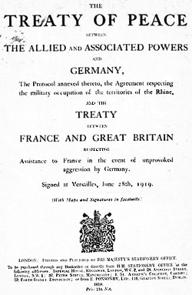
- This punished Germany by forcing them to accept official guilt for starting the war, making them pay £6.6 billion in reparations, reducing their army to 100,000 men, taking away their tanks, submarines and planes, taking 13% of their land and n12.5% of their population away, taking all their overseas colonies, demilitarising the Rhineland (border with France) and forbidding them from uniting with Austria (Anschluss).
- The Germans were outraged. They called the Treaty a “diktat” (dictated peace) and accused the Weimar Government of “stabbing them in the back” by agreeing to such harsh terms. People began to look to other politicians to rule Germany in replacement of the Social Democrats.

Other opposition to the Weimar Government

- The German communists continued to create riots around Germany, even after the Spartacist Revolution failed. Freikorps regiments were used repeatedly by Eberts government to put down unrest..
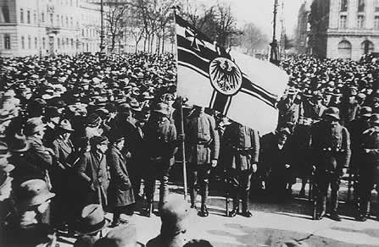
- The right wing also hated the Social Democrats. The Freikorps themselves openly opposed Ebert in 1920 when they supported Wolfgang Kapp in his attempt to take over the country (Kapp Putsch). It was only the workers of Berlin going on strike and refusing to help the Freikorps that stopped the Putsch.
- Over 200 people connected to the Weimar Government were assassinated between 1919 and 1923. The most famous was Walther Rathenau, a prominant politician who had been involved with the armistice and the Treaty of Versailles. These assassinations showed how much people disliked their new government and fostered public sentiment that they were unable to stop the violence on the streets.

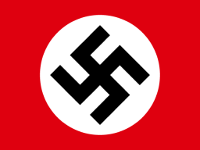
The beginnings of the Nazi Party

- Anton Drexler had a party called the German Workers Party. Hitler joined this in 1920 and soon had become its leader. He re-named it the National Socialist German Workers Party (NSDAP/Nazi Party).
- He gave the party a new flag and a new private army to protect it (the Sturmabteilung (SA/Brownshirts))
- The party was small and would meet in beer houses. It began to attract attention because of Hitler’s powerful speeches, especially his rants against the Treaty of Versailles. The SA would also physically intimidate opponents, especially the communists.

1923 – The invasion of the Ruhr, hyperinflation and the Munich Putsch

- Germany paid her first reparation payment in 1921 but couldn’t afford the 1922 payment.
- France and Belgium decided to invade Germany and take the payment by force. They invaded the Ruhr, Germany’s main industrial area, to take goods.
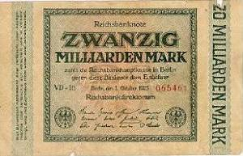
- The Germans reacted with passive resistance. They went on strike and refused to make the goods that the French and Belgians wanted. They sabotaged factories and flooded mines.
- The French and Belgians reacted with violence: shooting some Germans and expelling some others.
- The Weimar Government supported the strikers by printing more money to pay them so that they could afford to keep striking.
- Too many notes in the economy meant that prices went out of control. November 1923 was the worst month: bread cost 201,000,000,000 marks.
- People had to carry their wages home in wheelbarrows. Prices went up so fast that a day’s wages would just buy a cup of coffee the next day. The middle classes and the elderly suffered badly as their savings and pensions were wiped out.
- Hitler chose November 1923 as the moment to attempt his Munich Putsch. He thought people were so fed up of their situation that they would support another leader. The Putsch was easily stopped and he ended up in prison. He got very useful publicity from his trial and wrote Mein Kampf.
- Hyperinflation ended in November/December 1923 as Stresemann introduced the Rentenmark.

1924-9 – the Stresemann Years

- Gustav Stresemann was Germany’s Chancellor in 1923-4 and her Foreign Secretary after that.
- He helped Germany get back on her feet in two main ways
  - Economic measures: the Rentenmark, the Dawes Plan 1924 (800,000,000 mark loan from the USA), the Young Plan 1929 (reduced Reparations payments by 67%)…
  - International relations: the Locarno Treaties 1925 (Germany and France agreeing their border), Germany joining the League of Nations 1926, the Kellogg-Briand Pact 1928 (over 60 nations agreeing not to go to war)…
  - This increased the amount of money and foreign goods in Germany. People had more money to spend and the standard of living rose.
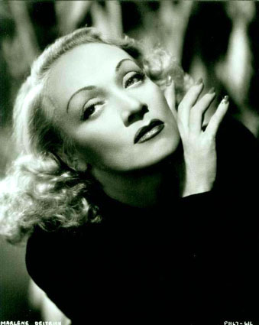
  - This was an age of cinema, clubs, sex, modern art and architecture, industry, radios, cars. Many urban people loved it; many rural people deeply disapproved.
  - On the surface, Germany was doing well. Underneath, there were problems: Germany was dependent on foreign loans and not making enough of her own money yet to stay afloat.

1929 – the Wall Street Crash and its impact on Germany
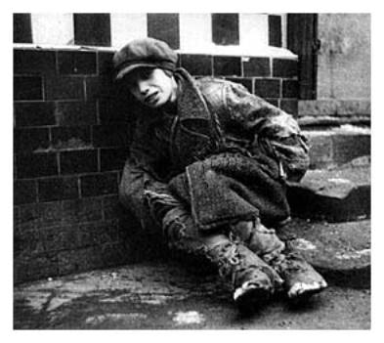
- In 1929, the USA’s economy collapsed. They recalled all their loans. Germany’s money stopped and they spiralled into Depression.
- Unemployment rocketed. It peaked at 6,000,000.
- People lost their homes and had to live on the streets, scavenging on rubbish tips for food.
- The Weimar Government dealt with it poorly – they refused to print more money but raised taxes and cut wages instead. This increased people’s suffering.
- Violence began to break out again as people got desperate. The Weimar Government failed to deal with it.

1929-33 – the increased popularity of the Nazis and Hitler becoming Chancellor

- The Depression played into the hands of the Nazis: people were desperate and wanted a saviour.
- The Weimar Government’s inefficiency made people look for an alternative government. President Hindenburg had to start running Germany using Article 48 which was unpopular.
- The Nazis used propaganda very well to advertise themselves as the party to solve all the problems: posters, meetings, radio broadcasts, the SA soup kitchens, the “Hitler over Germany” campaign.
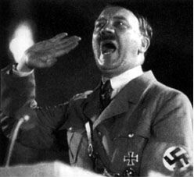
- Hitler used his great speaking talents to promote himself as the Saviour of Germany. He came across as dynamic and a powerful leader.
- The SA also beat up opponents, especially the Communists who would naturally appeal to the workers.
- Nazi votes rose. Election results:
  - 1928: 12 seats.
  - 1930: 107 seats.
  - July 1932: 230 seats.
  - Nov 1932: 196 seats (The SA’s campaign of violence began to have a negative impact).
  - Hitler asked to be Chancellor but Hindenburg (the President) refused. He chose von Papen, then von Schleicher but neither man could get a majority in the Reichstag to make the country run properly. Hindenburg had to keep ruling with Article 48. Eventually, Hindenburg had no options left and made Hitler Chancellor on 30 January 1933.

Nazi Germany – 1933-45

1933-4 – Hitler’s consolidation of his power and his rise to become Führer

  - Hitler needed a majority to get things done. He called another election for March 1933.
  - The Communist vote was crushed through the Reichstag Fire and the following Emergency Decree.
  - The Nazis got 288 seats in the election, NOT a majority. They had to join with the DNVP/ Nationalists to get the majority.
  - Hitler then used this majority to quickly pass the Enabling Act which allowed him to make laws without consulting the Reichstag for the next 4 years.
  - With the power of the Enabling Act, Hitler then:
  - Banned opposing parties and put leaders in concentration camps.
  - Banned Trade Unions.
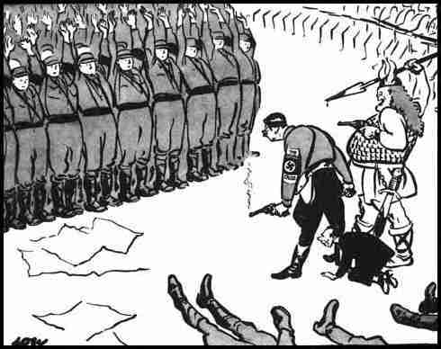
  - Put Nazis in charge of all state governments.
  - Used fear and intimidation to make sure people didn’t challenge the Nazis.
  - The SA, under their leader Röhm, became a threat due to their numbers and military training and so Hitler had 400 leaders of the SA shot on the Night of the Long Knives.
  - When Hindenburg died, Hitler made himself Chancellor and President combined and called his knew role Führer. The army were made to swear an oath of personal loyalty to Hitler.
  - No major group remained to challenge Hitler: he had TOTAL POWER in his One Party State.

Propaganda – keeping people supporting the Nazis

- Hitler set up the cult of the Führer, presenting himself as the greatest saviour of Germany. His image was used very carefully – he was only ever shown serving Germany.
- Goebbels (Hitler’s Propaganda Minister) made sure that people were bombarded with information to keep them loyal to the Nazis.
- Posters, pictures, art exhibitions and films were all made to show how great the Nazis were.
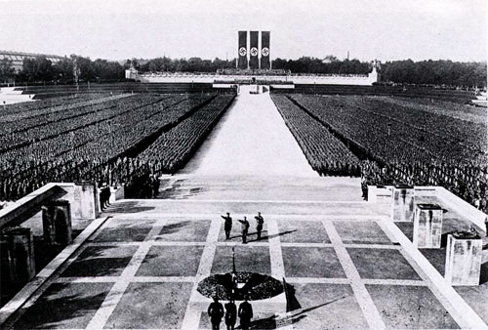
- Hitler’s speeches were regularly broadcast on the radio to remind people of how much the Nazis were improving their lives. Cheap radios were sold to people and connected up to loudspeakers so that everyone could hear.
- The newspapers were banned from printing anything that hadn’t been checked by the Nazis first (censorship).
- Great rallies were held, such as those at Nuremberg, to show people how organised and powerful the Party was.
- In 1936, Hitler used the Olympic Games to showcase to the world how efficient, modern and advanced the German nation was.

Intimidation – keeping people supporting the Nazis

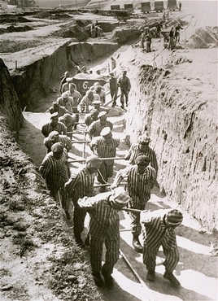
- The concentration camps were used to imprison anyone who went against the Nazi state. These were run by the SS. In the camps, people were expected to work to benefit Germany. They were often worked to death with very long hours and insufficient rations.
- The Gestapo (secret police) would go round checking that people were being loyal to the Nazis. People who weren’t would often be taken off in the middle of the night for torture or to be taken to a camp.
- Germany was subdivided into tiny blocks of about 30-40 houses. Each block would have a Nazi living there who would keep an eye on all the families and report to the police and the Gestapo if they noticed anti-Nazi behaviour.
- Children in the Hitler Youth were expected to spy on their parents and neighbours.

1933-9 – how the Nazis changed the lives of young people

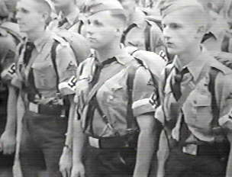
- Hitler wanted to indoctrinate young people to become perfect Nazis. He did this in two ways: the Hitler Youth Movements and through Education.
- The Hitler Youth Movements:
  - 4 different groups, 2 for girls, 2 for boys.
  - Boys trained to be soldiers: marching, camping, weapons training, fitness training.
  - Girls trained to be good mothers: domestic training, fitness training.
  - Both groups trained in utter loyalty to Hitler: listening to Mein Kampf, saluting the swastika, singing Nazi songs, reporting on “anti-Nazi” activities in their families and neighbourhoods.
  - Education:
  - New curriculum. Maths questions promoted messages of war and getting rid of minorities, History focused on the Nazi Party, Geography focused on the “Greater Germany”, Biology focused on recognising the Aryan race…
  - New resources: History books were rewritten without German defeats, Story books were written warning children of the dangers of the Jews.
  - Boys were educated to be soldiers, girls educated to be mothers. They had separate timetables.
  - Lots of PE lessons for everyone to keep everyone fit and healthy for their new roles.
  - Teachers had to join the Nazi Teachers’ Association or lose their jobs.
  - Jewish pupils were persecuted in lessons. They had to leave German schools in 1938.
  - Membership of the Hitler Youth became compulsory in 1939. About 7,500,000 children were members; about 1,000,000 refused.
  - Some young people chose to join anti-Nazi groups like the Swing Movement and the Eidelweiss Pirates.

1933-39 – how the Nazis changed the lives of women
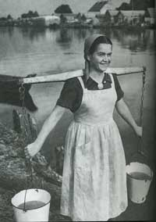
- Women were expected to be mothers. Many women were forced to leave their jobs.
- Medals were awarded for women who had large numbers of children.
- People were encouraged to get married and have children by being offered marriage loans which were reduced each time a child was born.
- Women were discouraged from wearing make-up, smoking and dieting.

1933-39 – how the Nazis changed the lives of workers

- The German economy was still suffering badly from the Depression. Hitler set up two 4-year plans to get the economy back on track. This had several results for ordinary workers.
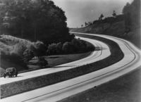
- Unemployment was tackled by creating massive public works programmes such as the building of the autobahns. Millions of men were given jobs through this, although they were paid poorly.
- Men aged 18-25 were made to join the RAD (Reich Labour Service) for 6 months. They did hard manual labour such as tree felling and ditch digging.
- All workers joined the DAF (German Labour Front) which controlled the workers and settled disputes between them and their employers. It persuaded employers to improve working conditions in factories.
- The KDF (Strength through Joy) organisation was set up to organise the leisure time of the workers, providing them with cheap theatre tickets, cruises, skiing holidays and saving up for VW Beetles.
- The government took control of prices, wages, profits and imports which stopped big businesses from running their affairs in their own way.
- Jewish small businesses were closed down allowing other German small businesses to flourish.
- Farmers were given help in paying off loans but were given quotas for production to meet which limited their freedom.
- In the run up to WW2, German men began to be conscripted into the army and more and more factories were set up for arms production. Germany tried to achieve autarky (self-sufficiency) so that they could keep fighting when other countries stopped trading with them.

1933-9 – how the Nazis changed the Churches
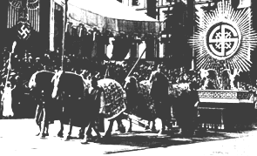
- In 1933, Hitler signed the Concordat with the Pope. The Nazis and the Catholic Church agreed to keep out of each others’ affairs.
- The Protestant Church was reorganised into the Reich Church and given new Nazi bishops. Protestant pastors who opposed the Nazis were arrested and taken to concentration camps.
- The Faith Movement was set up as an alternative to Christianity. It was based on pagan rituals.
- Christmas carols and religious studies were phased out of schools. Church schools were closed.
1933-39 – how the Nazis changed the lives of minorities

- The Nazis believed in Aryan superiority. Anyone who didn’t fit in with their idea of a top class human being had to be removed from society.
- Vagrants and the homeless were taken to camps to be re-educated and taught how to work so that they could become useful German citizens.
- Homosexuals were sent to concentration camps.
- Blacks and the mentally ill were sterilised so that they couldn’t reproduce or killed.
- Gypsies were sent to concentration camps and later (during WW2) exterminated with the Jews.
- Jews suffered badly in Nazi Germany: boycotts were placed on their shops, they were forbidden from using public services, they had to be identified by wearing a yellow Star of David and so on. Key moments of persecution were
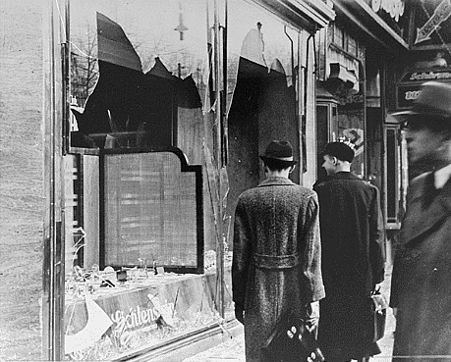
  - 1935: the Nuremburg Laws. This took away their German citizenship and banned them from marrying or having sex with Germans
  - 1938: Kristallnacht. This was a physical attack on Jewish businesses, homes and synagogues, causing colossal damage. Many Jews were arrested and taken to concentration camps. The survivors were given a 1 billion Reichsmark bill to clear up the mess.

Life in Nazi Germany during WW2 (1939-45)

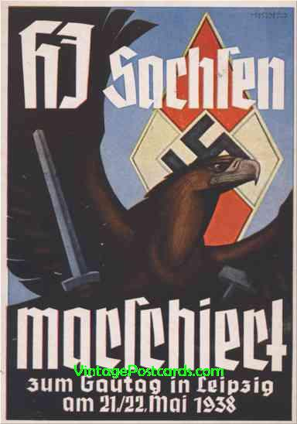
- Rationing was introduced early on. People got used to a monotonous diet, a lack of clothes, little hot water and soap.
- Propaganda increased, especially when Germany needed greater support for the war such as during the Russian campaign of 1941-45. Propaganda films were particularly important.
- From 1942, Germans began to experience bombing raids on their major cities from British and American bombers. Hundreds of thousands of civilians were killed.
- In 1944, all workers had to go into armaments production. Women were back into work; their children were in day care. People had to work longer and longer hours.
- Jews, gypsies and other minorities began to be deported to Death Camps where they were exterminated.

Opposition to the Nazis

- Young people opposed the Nazis:
  - The Edelweiss Pirates. Working class movement who beat up the Hitler Youth and helped concentration camp escapees.
  - The Swing Youth. Middle class movement who listened to jazz music and went clubbing.
  - The White Rose movement. University students who spread anti-Nazi leaflets and urged Germans not to support WW2.
    - The churches opposed the Nazis:
  - Protestants set up the Confessional Church which was anti-Nazi
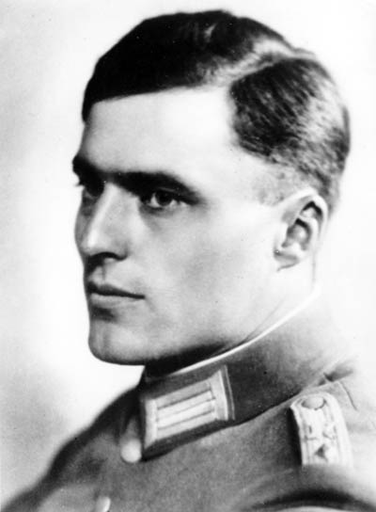
  - Protestant pastors such as Dietrich Bonhoeffer and Martin Niemoller spoke out against the Nazis. Bonhoeffer was also involved in sabotage work
  - The army opposed the Nazis:
  - In July 1944, Count von Stauffenberg attempted to assassinate Hitler with a bomb in a suitcase.
  - Army officers became more and more critical of Hitler in 1943 as the war went very badly.

If you want to check that you really know your stuff, can you answer these key questions and justify your answers fully?

- Why was it so difficult for the Weimar Government to rule Germany between 1919 and 1923?

- Which was the bigger problem for the Weimar Government: the Treaty of Versailles or the Weimar Constitution?

- Why did Germany suffer from hyperinflation in 1923?

- Why did the Munich Putsch fail?

- How important was the Munich Putsch in helping Hitler become ruler of Germany?

- How far did Germany get back on its feet between 1924 and 1929?

- Which was worse for the Weimar Government: hyperinflation or the Great Depression?

- Was the Depression or Nazi Propaganda more important in helping Hitler become Chancellor in 1933?

- What was the most important thing Hitler did between January 1933 and August 1934 to get total control of Germany?

- Why did Hitler use both propaganda and intimidation to stay in control of Germany?

- Who benefited most and who lost out most from Nazi rule?

- Which group opposed the Nazis most effectively?

- How did WW2 affect the Nazi regime?

